The gateway to America
A piece of Swedish radio history
By Sten-Eric Petersson, SM6DQO

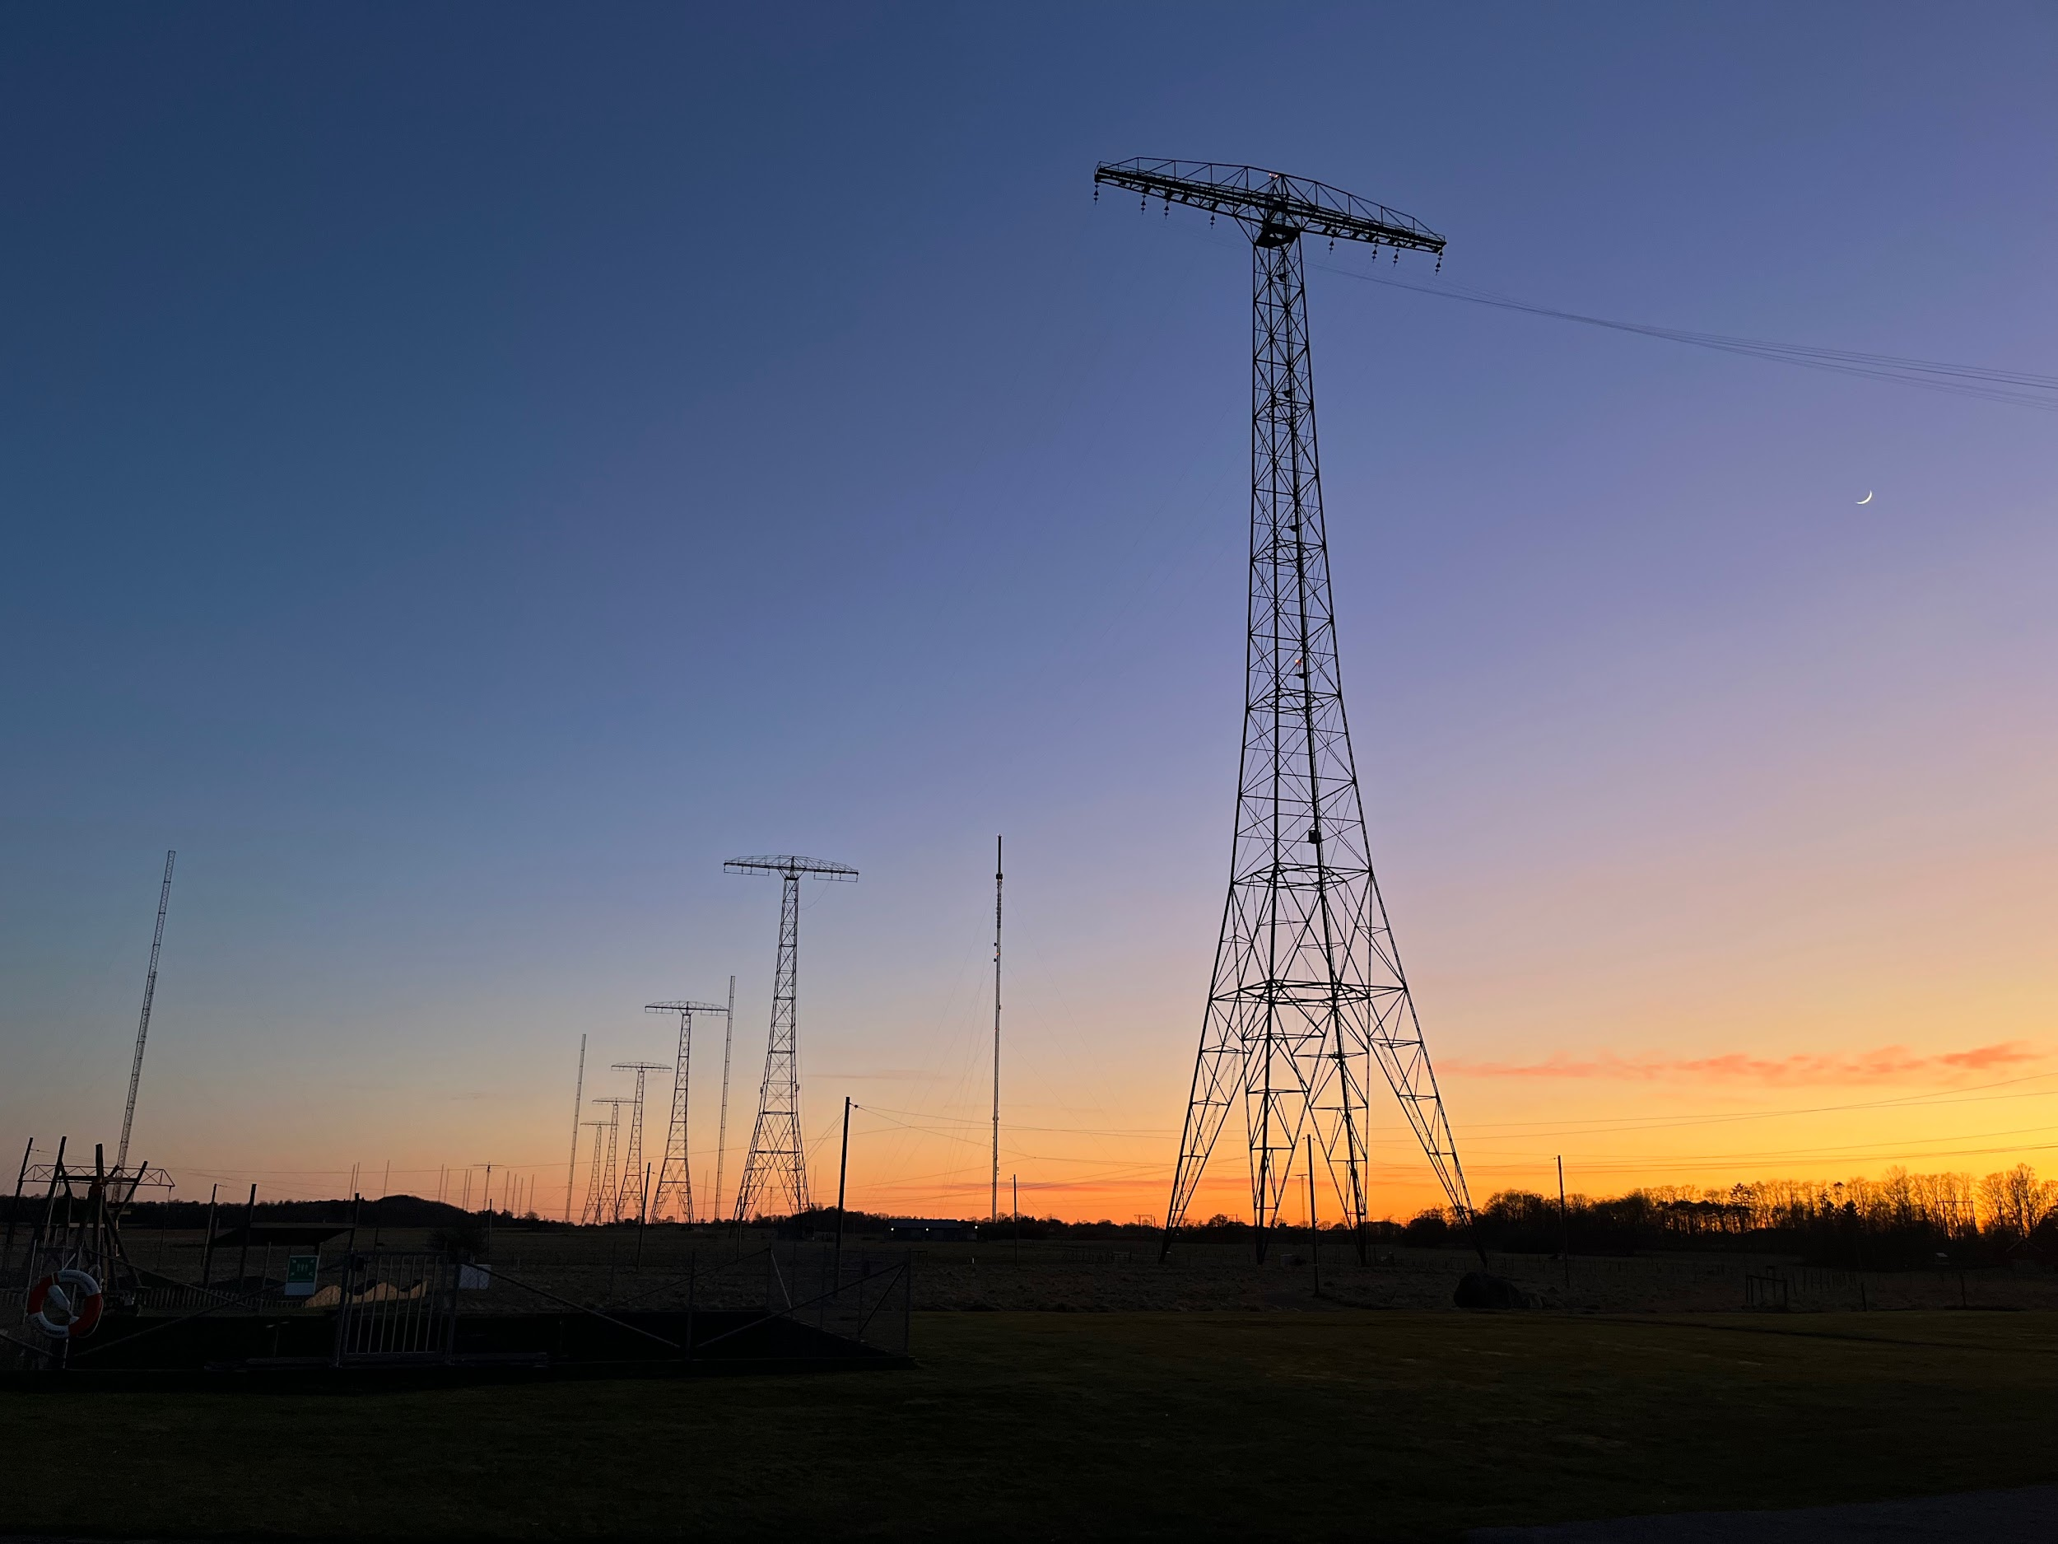

In the summer of 1925 a completely new international radio system was inaugurated in Sweden for Point to Point traffic with USA and Europe. The system consisted of several parts in different locations in western Sweden, Göteborg, Varberg, Kungsbacka and Karlsborg.
The radio station at Grimeton outside Varberg is well known to many, but the fact that the radio stations in Kungsbacka and Karlsborg also came to play an equally important role in the development of radio in Sweden is not so well known. Much radio history has already been written but perhaps not that much about how radio came to Sweden at the turn of the last century and how the country developed in terms of radio.

Telegraph by wire
Before Marconi and others who demonstrated radio waves as a new form of telecommunications one had to rely on telegraph traffic via overhead line or ground cable. The Swedish Telegraph Authority was established in 1853 with a first telegraph line between Stockholm and Uppsala. The whole country was connected in 1857 and traffic with USA was in operation from 1866.
The Swedish state railways inaugurated the western main line between Stockholm and Göteborg in 1862 with telegraph connection between all major stations. The train dispatcher could inform the surrounding, first with telegraphy by hand or pointer telegraph and later with a telephone system. In connection with these improved communications in several areas, Swedish Standard Time was introduced on Jan 1st 1879.

The Navy was first
During the autumn of 1899, the Swedish warship Balder was on a long voyage tour in Europe under command of Commander JWL Siedner. In early November Balder visited the English naval station in Devonport and in a report home to the Navy Administration in Stockholm Siedner wrote that he had been informed that ships during the year’s exercise:
”Attempts were made with telegraph without wire and appeared to be successful.

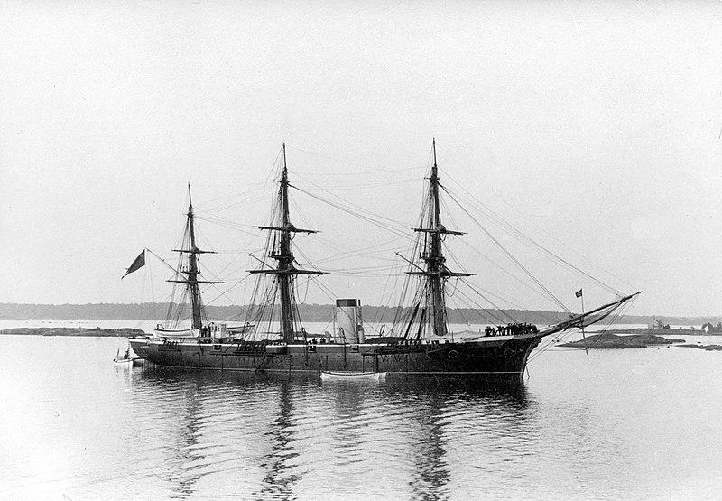
Swedish Navy warship ”Balder”

The report aroused interest in the Marine department in Stockholm and a decision was made to try to borrow equipment from The Marconi Company in England to be used during exercises with the Navy squadrons. The Marconi Company stood first positive to the proposal but became increasingly hesitant and announced:
”The system in itself is a complete success, and it is both a waste of time and money to continue with small experiments such as you suggest”
In the meantime, contact had been made with AEG Company in Germany where the Marine Department had ordered two pieces of equipment. Tests were first carried out in the spring of 1900 in Karlskrona and later during the summer in the Stockholm archipelago. The Marine Department wrote in its report:
…In the experiments exceptionally beautiful results have been achieved…
These attempts were probably the first time radio was successfully introduced in our country.

Spark Telegraph
After initial experiments in 1901 additional equipment was ordered from AEG. Spark telegraph stations were established in Karlskrona, Oskar Fredriksborg at Vaxholm and at Fårösund on the Island of Gotland. Later, additional stations came on the air in Trelleborg, on Skeppsholmen in Stockholm and in Boden. Equipment was also installed in the warships Oden, Thor, Niord and Clas Uggla. In total, spark telegraph stations were installed in 34 Swedish navy war ships.

The Navy’s first station in Göteborg was built in 1907 at Oscar II Fort as ”Älvsborgs Gnistsignal Station”. The antenna system was placed directly on the bedrock and didn’t give at all the result that was expected. The station was moved to ”Nya Varfvet” and a much more suitable place called ”Gnistängen”

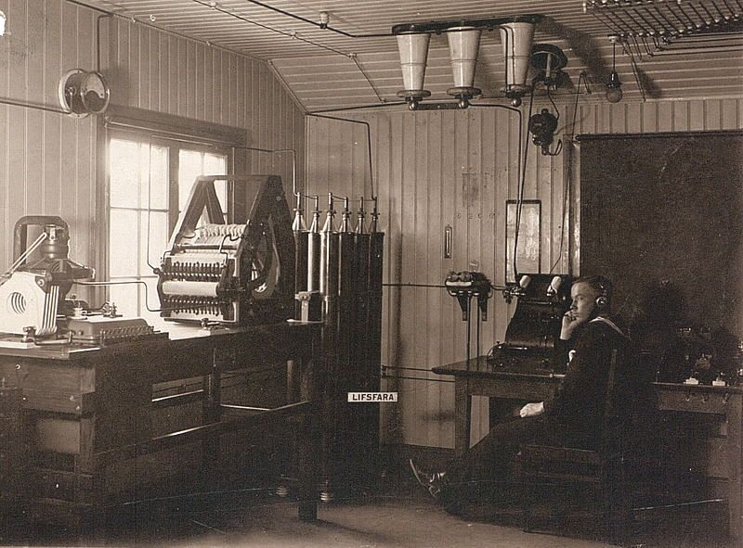
Gnist telegraf station Göteborg GSG

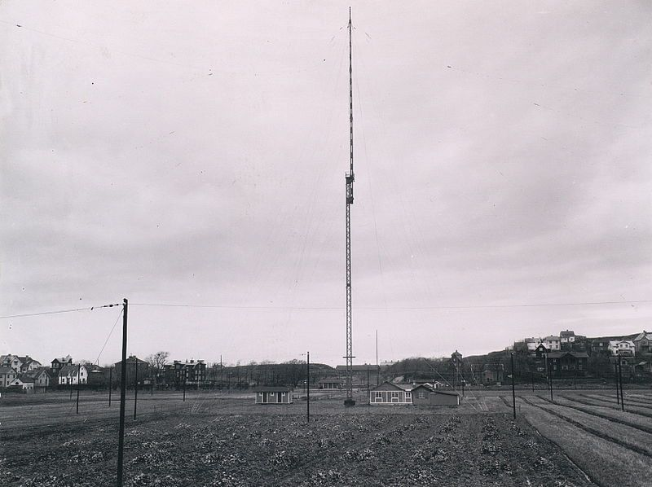
Gnistängen

The Swedish Telegraph Authority also planned a station in Göteborg for the expected civilian radio traffic. An agreement of cooperation was reached, and in 1911 the station was opened to both military and civilian traffic.
The Swedish coastal stations of that time used call signs such as GSK or GSG, ”Gnist telegraf station Karlskrona” or ”Gnist telegraf station Göteborg”. After the international radio conference in London in 1912, new rules came into effect. Sweden was assigned call signs in the series SAA - SAZ for coastal stations and SFA-SMZ for ship stations. Karlskrona became SAA and Göteborg SAB.Call signs such as SGON for ship stations and SE-CFP for aircraft were only introduced later.
The outbreak of World War 1 showed how vulnerable Sweden was when it came to establishing telegraph connections with the outside world. Cables were easy to sabotage and cut off. The lack of telecommunications, first of all with America, became increasingly annoying. New reliable connections had to be established.

Major station for Point to Point traffic
The Swedish parliament decided in 1915 that a major station for correspondence with other countries and a liaison center for civil and military coordination should be built at Karlsborg in Västergötland. Karlsborg fortress was in case of war residence of the Swedish government and storage place for the Swedish Riksbank.
In December 1917 the station was completed and taken into service as the only station in Sweden for fixed-route radio traffic. Two spark transmitters were delivered from Telefunken in Germany. The most powerful one at 80 kW was considered as the strongest in Europe. The traffic was controlled from the telegraph station in Stockholm and initially consisted of press telegrams and weather reports to the merchant Navy. Later, Point to Point traffic was also established to several countries in Europe. The ambition to establish a permanent connection with USA was not fulfilled. Only sporadic contacts were achieved.

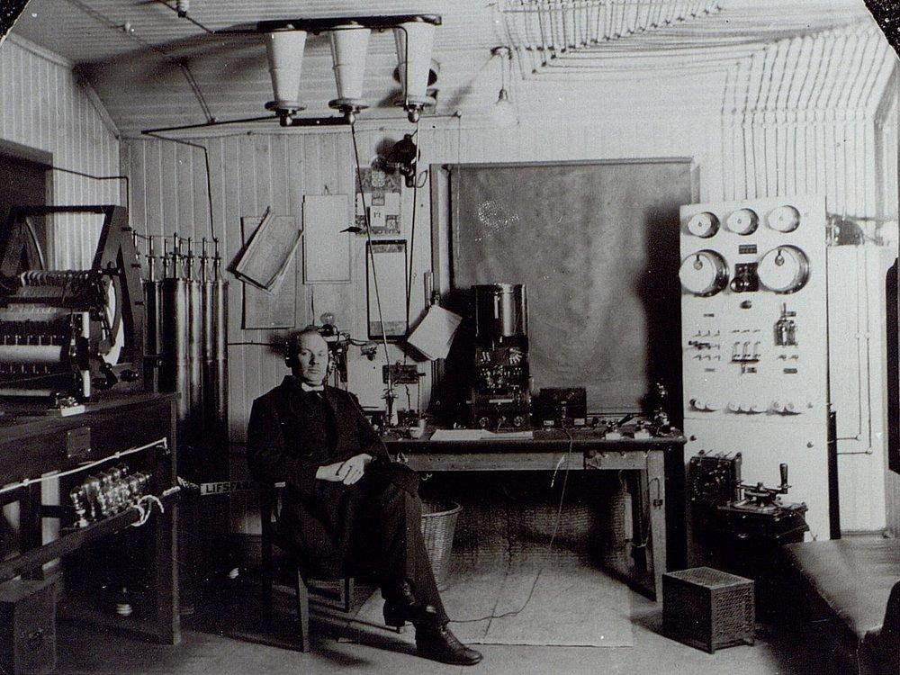
Karlsborg Radio

Tube transmitter
Already in 1922 the spark era was almost over in Karlsborg when a Telefunken 10 kW tube transmitter for longwave came to service. The new transmitter became a huge success. Later in 1923 tests were carried out daily with the Swedish passenger ship M/S Drottningholm during Atlantic voyages to and from New York.

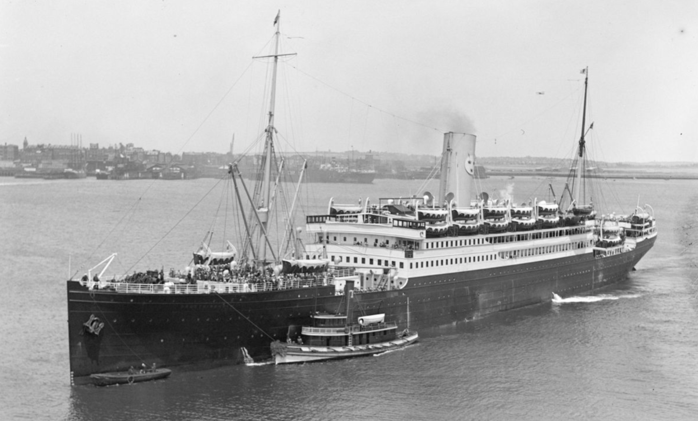
Swedish America Line M/S Drottningholm

The transmitter was also used for test transmissions of local radio programs for the general public and later became one of the main transmitters for AB Radiotjänst from the start in 1925 until 1927 while waiting for a new transmitter in Motala to come on the air.
Sweden was early on the air with public broadcasting. The program ”Children’s mailbox” started in September 1925 and was for a long time considered as one of the oldest radio programs in the world. The program started even earlier than the legendary ”Grand Ole Opry” from radio station WSM in Nashville, Tennessee.
The announcement ”Stockholm-Motala”, well known to Swedish listeners, maybe should have been ”Stockholm - Karlsborg” during that period.

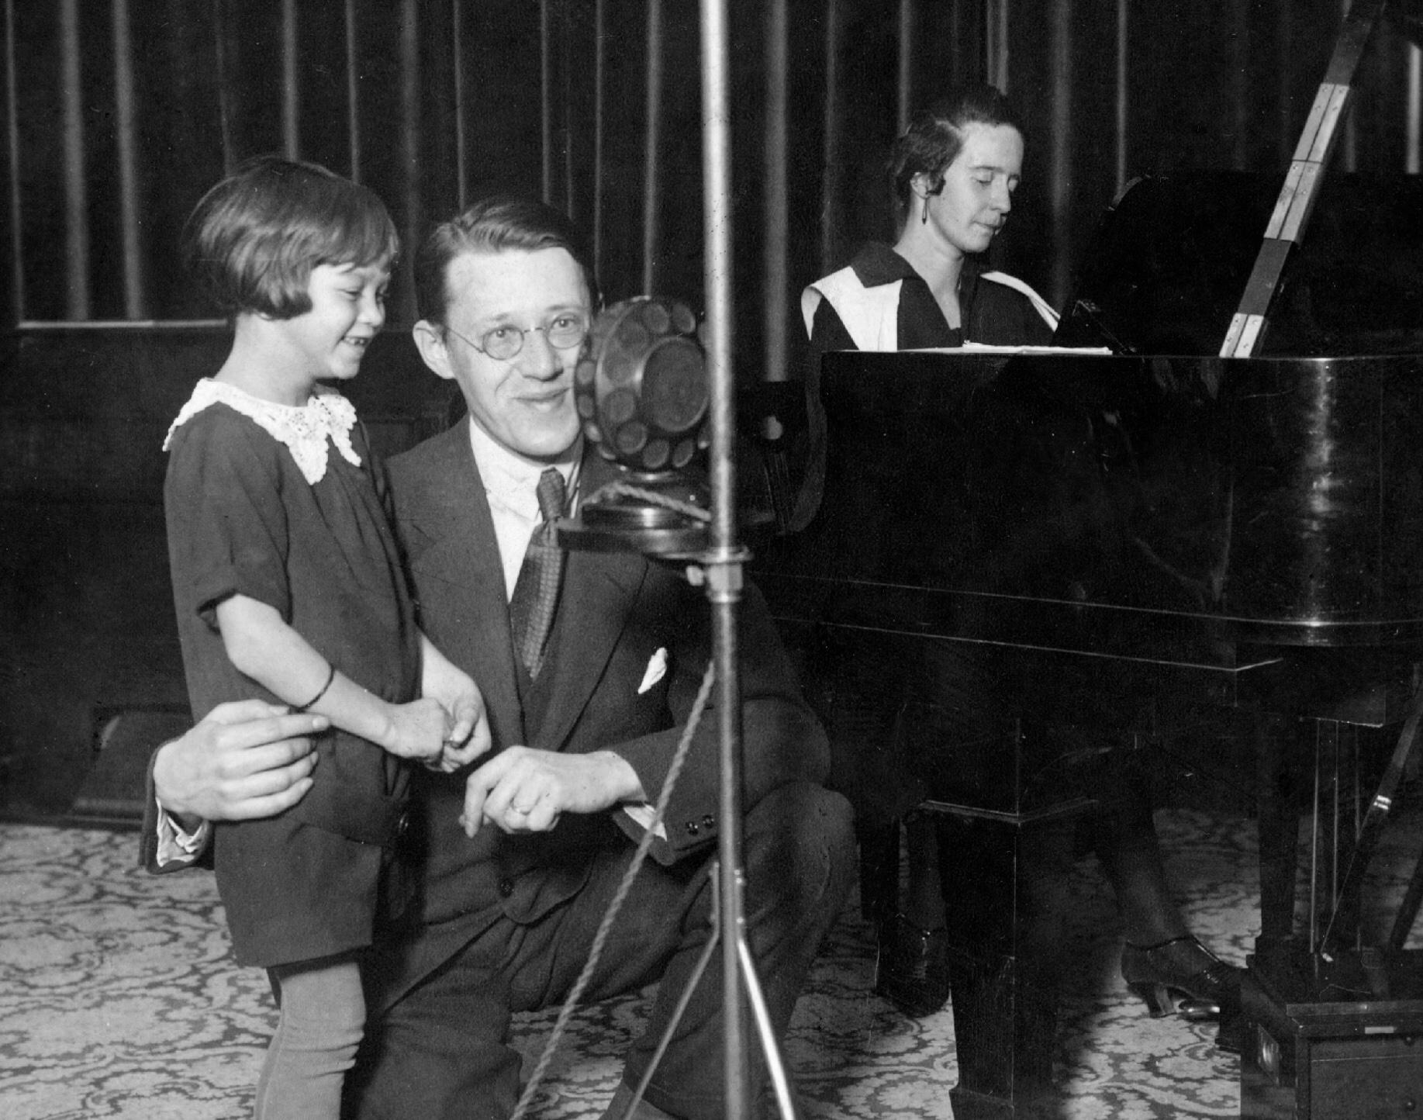 ”Children’s mailbox” (Barnens brevlåda) in 1925

America
After suggestion from the Sweden-America foundation the Telegraph Board decided to request for financial support to establish a new main station for Point to Point traffic with America.
Transmitters and receivers in USA were located in the area around New York. It was important that the radio signals not were affected by land area. The signals should therefore pass over water and preferably follow the great circle arc from USA, touching the most sudden tip of Norway and finally end up on the Swedish west coast. Transmitters and receivers should not be located too far away from a future radio control center in Göteborg.

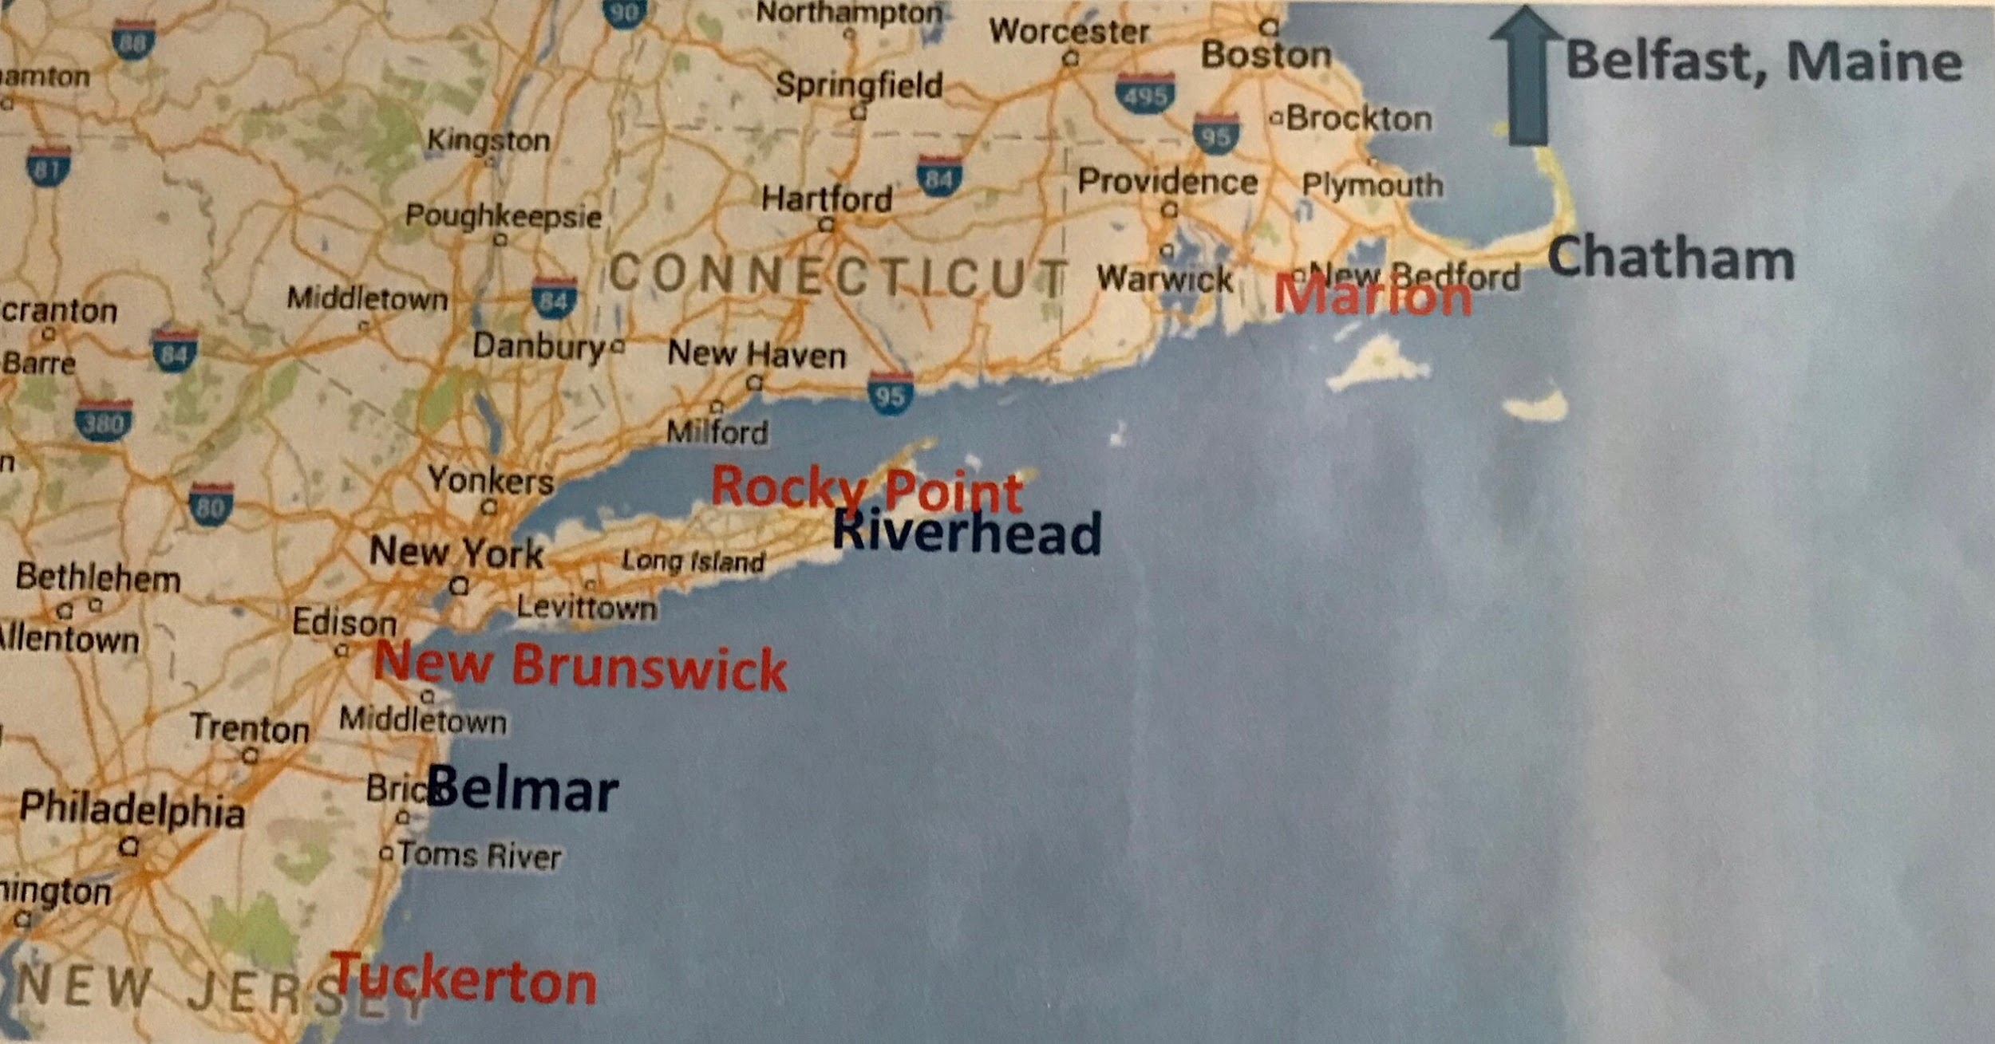
RCA transmitters and receivers in the New York area

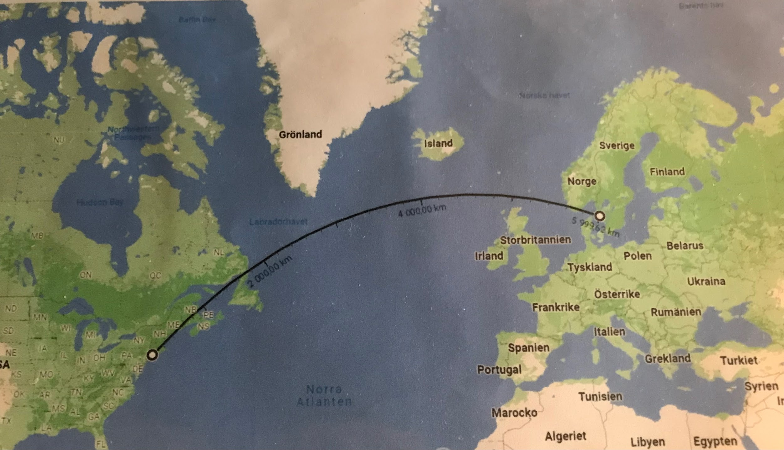
Great circle arc: New York - Swedish west coast

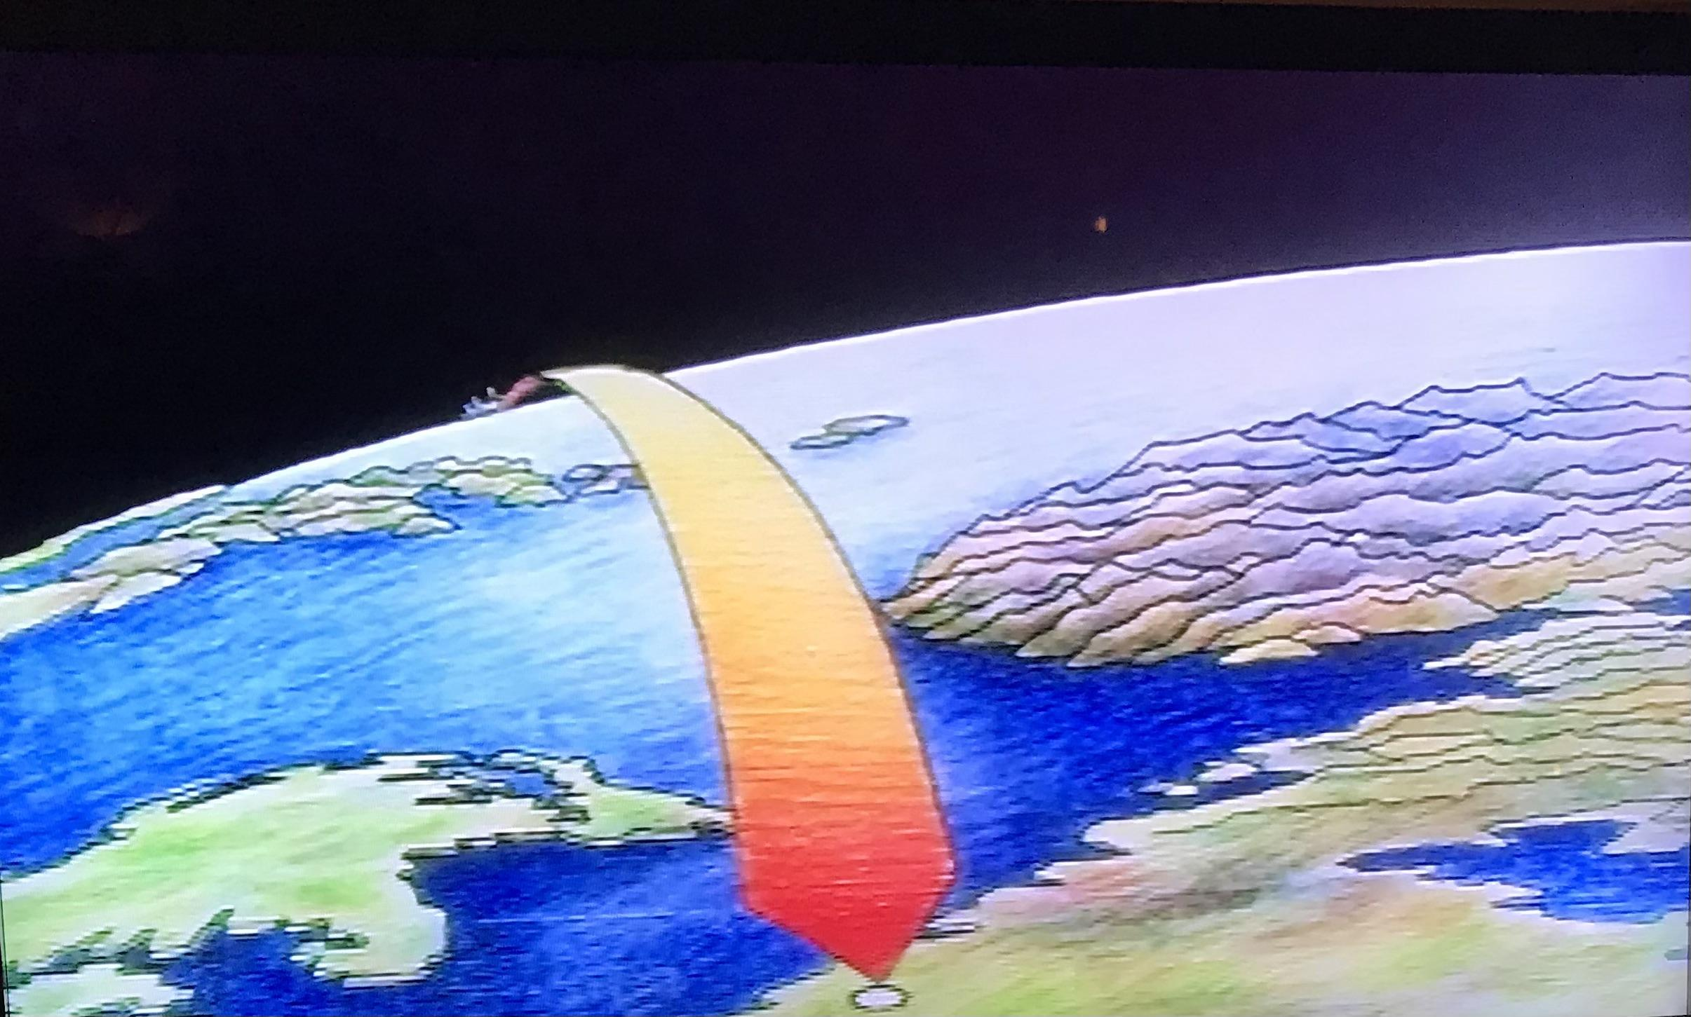
Grimeton and Kungsbacka on the west coast of Sweden

After a parliament decision in 1922, the construction of the new station could start. The transmitters came to be located at Grimeton, east of Varberg and the receivers at Kungsbacka, south of Göteborg. Both station buildings were designed in neoclassical style by Stockholm architect Carl Åkerblad.
The receiving station was built in Kungsbacka in 1923 with receivers from General Electric and RCA. A Longwire or Beverage antenna was chosen for frequencies around 18 kHz. The antenna was designed as a 2-wire telephone line, and suspended on 8,5 m high telephone poles 50 meters apart along a stretch of 13,4 km. Normally the antenna would run from the receiving station and follow the great cycle to the northwest towards the transmitters in the New York area. For various reasons it was chosen instead to let the antenna follow the great circle from the receiving station in direction southeast. After a process with a considerable amount of landowners about compensation for poles on their land, the antenna system could be tested during the summer of 1923 towards transmitters in USA and Europe.

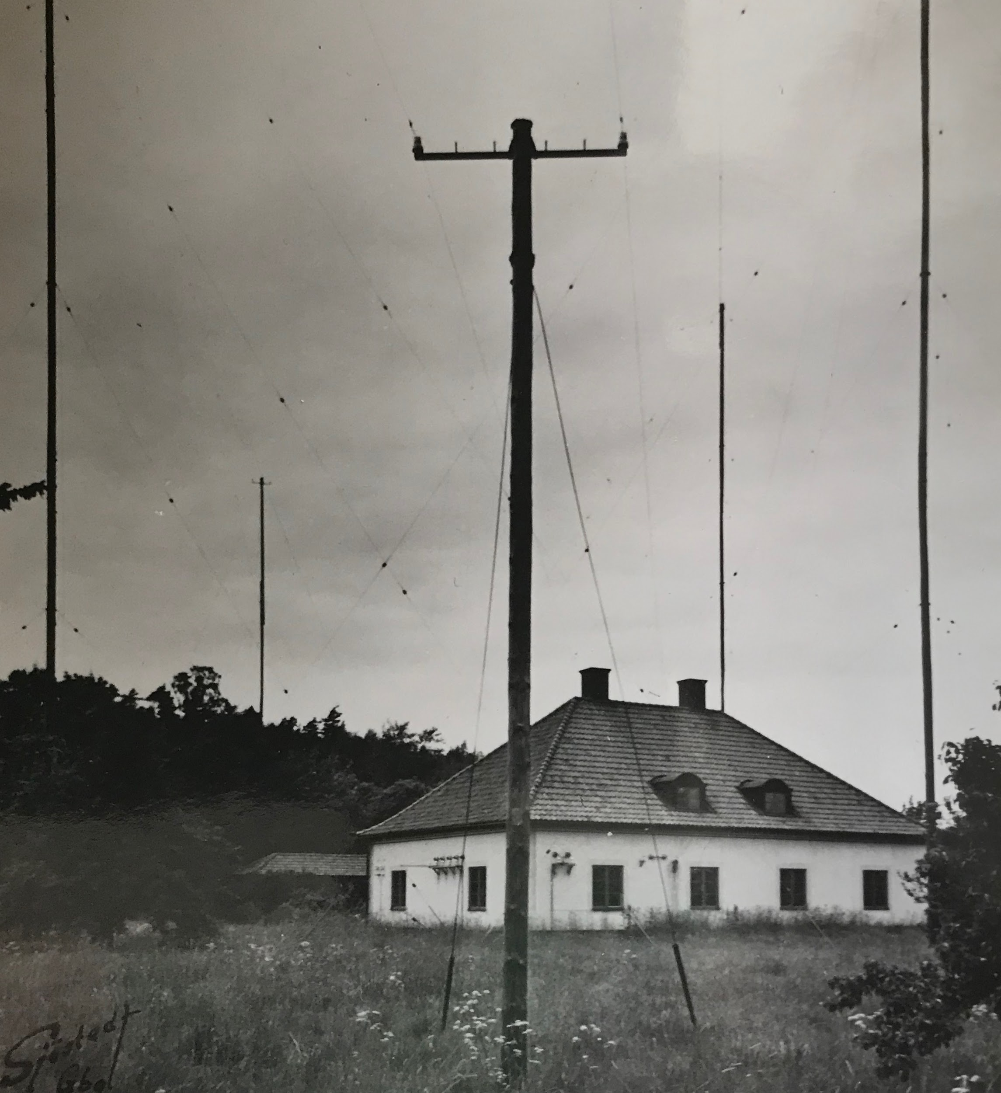
Beverage antenna and poles for HF-antenna

Ground survey at the future transmitter station in Grimeton was carried out in the autumn of 1922 for an antenna installation consisting of a 2,2 km long antenna system supported by 6 antenna towers at a hight of 127 m. The construction of the 6 towers was delayed due to a labor dispute and only started during the summer of 1923. During the autumn of 1924 the transmitters and antenna system were in place. Test transmissions towards America were successful. The station was ready for traffic.

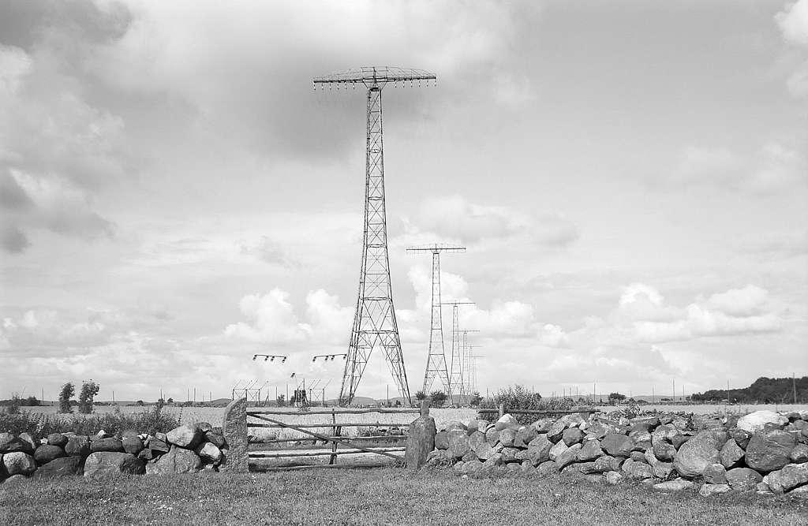
Antenna system Grimeton Radio

A radio control center was built at the telegraph station in Göteborg to coordinate all traffic from 10 dispatch locations, 6 for receiving and 4 for transmission.
All co-operating units of the new main station in Göteborg, Grimeton, Kungsbacka and Karlsborg were completed on October 31 1924. On December 1st the transatlantic link between Sweden and USA was opened.

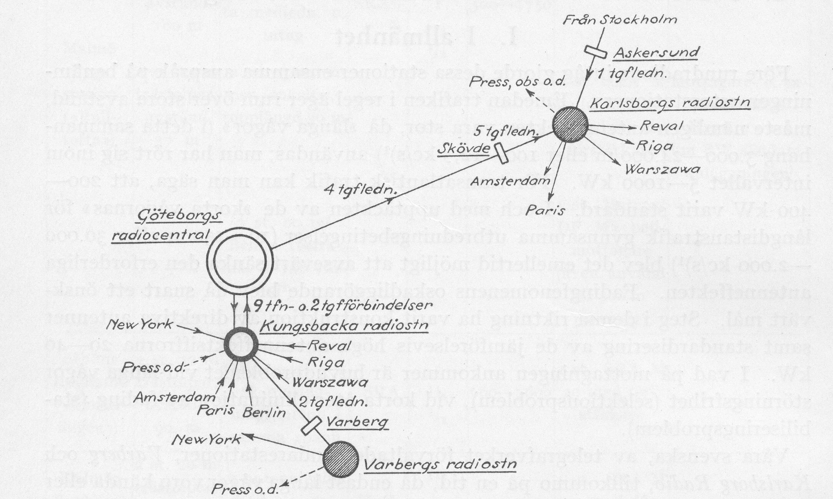
Network diagram of the complete radio system

USA which previously had a number of different radio links to foreign countries now also organized a radio control center for all traffic across the Atlantic:
Central Traffic Office, 64 Broad Street, New York
The Swedish - American radio network was now fully operational.



The Swedish King Gustav 5th inaugurates the main radio station on July 2 1925.

To inaugurate an international radiosystem for traffic between Sweden and USA was not a small event in 1925. The following could be read in the local press about the King’s visit:
On the Royal special train from Göteborg there were a large number of invited guests, including the two speakers of the Swedish parliament, several ministers, chairman and vice chairman of the state committee, head of the State Communications Authority, Chief of the General Staff, Chief of the Naval Staff, head of the Fortification Department and a large number of representatives of Swedish industry, trade and banking. Also invited was the American minister and representatives of the Danish and Norwegian telegraph boards.
Upon arrival at Varberg railway station the King was welcomed by the governor and The King’s song, performed by the Kronberg music corps.
The party then traveled in a motorcade, consisting of about 30 cars, to Grimeton Radio Station where the King was greeted by singing children waving Swedish flags. After the inauguration speech in the presence of RCA’s vice president, the legendary former radio telegrapher David Sarnoff, the Chief designer Ernst Alexandersson and the management of the telegraph board the following message was sent from the King to the American president Calvin Coolidge:

”The direct wireless connexion between our two countries, the successful result of Swedish and American engineering ability and organizing power, is now completed in all its details”

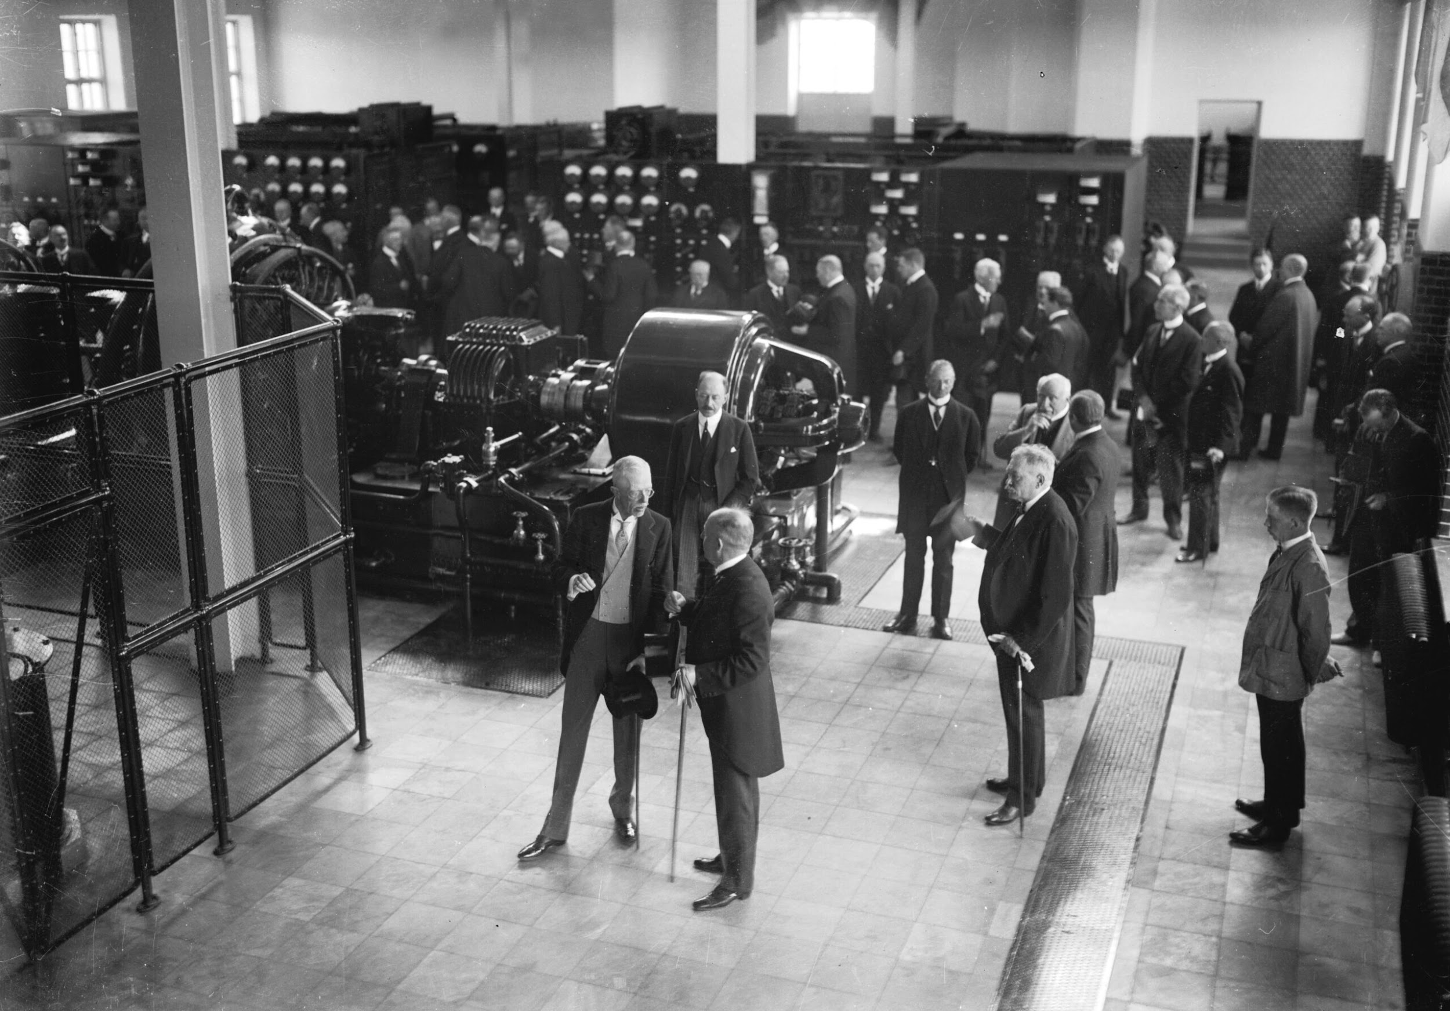
Transmitter hall Grimeton Radio

After the visit to the transmitting station in Grimeton the King continued to Kungsbacka to also inaugurate the receiving station. The King was received by the city’s officials and representatives from the Radio Bureau of the Telegraph board. During the visit to the equipment hall one of the receivers was specially set up for the royal visit. The party had the opportunity to hear the signals directly from New York in a temporarily connected speaker.

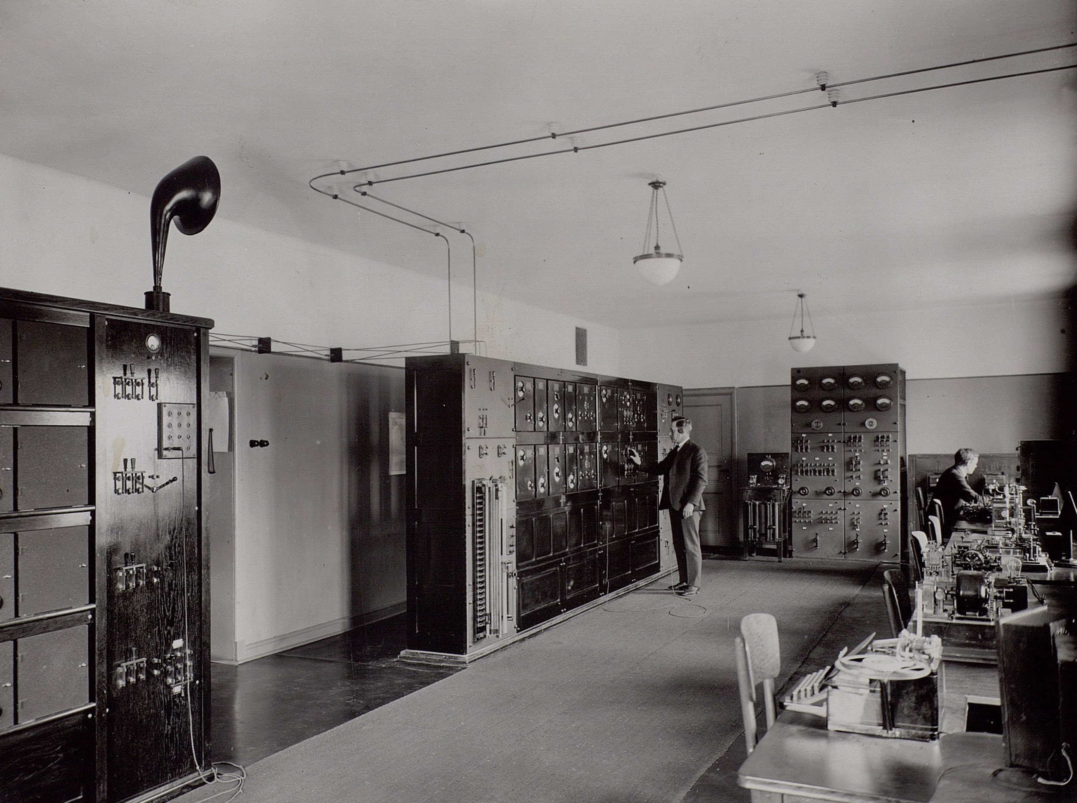
Receiver hall Kungsbacka Radio

The King then continued to the telegraph station in Göteborg to visit the Radio Control Center.
President Coolidge replied to the King’s message and noted the crucial importance of the new radio facilities for relations between Sweden and USA.
The direct radio link to USA became an immediate success. In ”Svensk Trafiktidning” a magazine from 1925 one could read the following statement from one of the telegraph company’s major customers:
It is our pleasure to announce that we have used Grimeton Radio Station since its opening, at first sporadically, and then later for the entire transatlantic telegraph correspondence since it has been shown that the telegrams forwarded in this way have been delivered not only with impeccable accuracy but also with a considerable saving of time.
Respectfully
Svenska Handelsbanken AB

Radio Control Center
The Radio Control Center in Göteborg could simultaneously both transmit traffic via Grimeton and Karlsborg and receive traffic via Kungsbacka. Contact with the staff at the stations about starting transmitters and receivers or changing frequencies was first carried out by hand-held telegraphy but was soon changed to a mechanical system.
Incoming telegrams from telegraph stations in Sweden or abroad were initially received on strip printers as morse code in the form of dashes or as a wavy line.

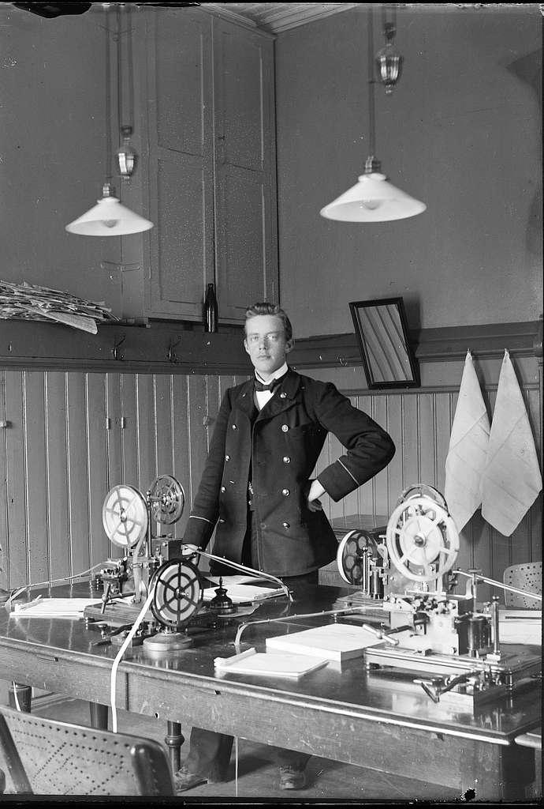
Strip printers

Dashes

Wavy line

The signs on the paper strip then had to be read manually and written on a ”keyboard perforator”, a typewriter for morse code where each character was punched out on a perforated strip. A time-consuming duplication of work. The punched strip could then be connected to a strip reader for printing on paper or to an auto transmitter for transmission on radio.

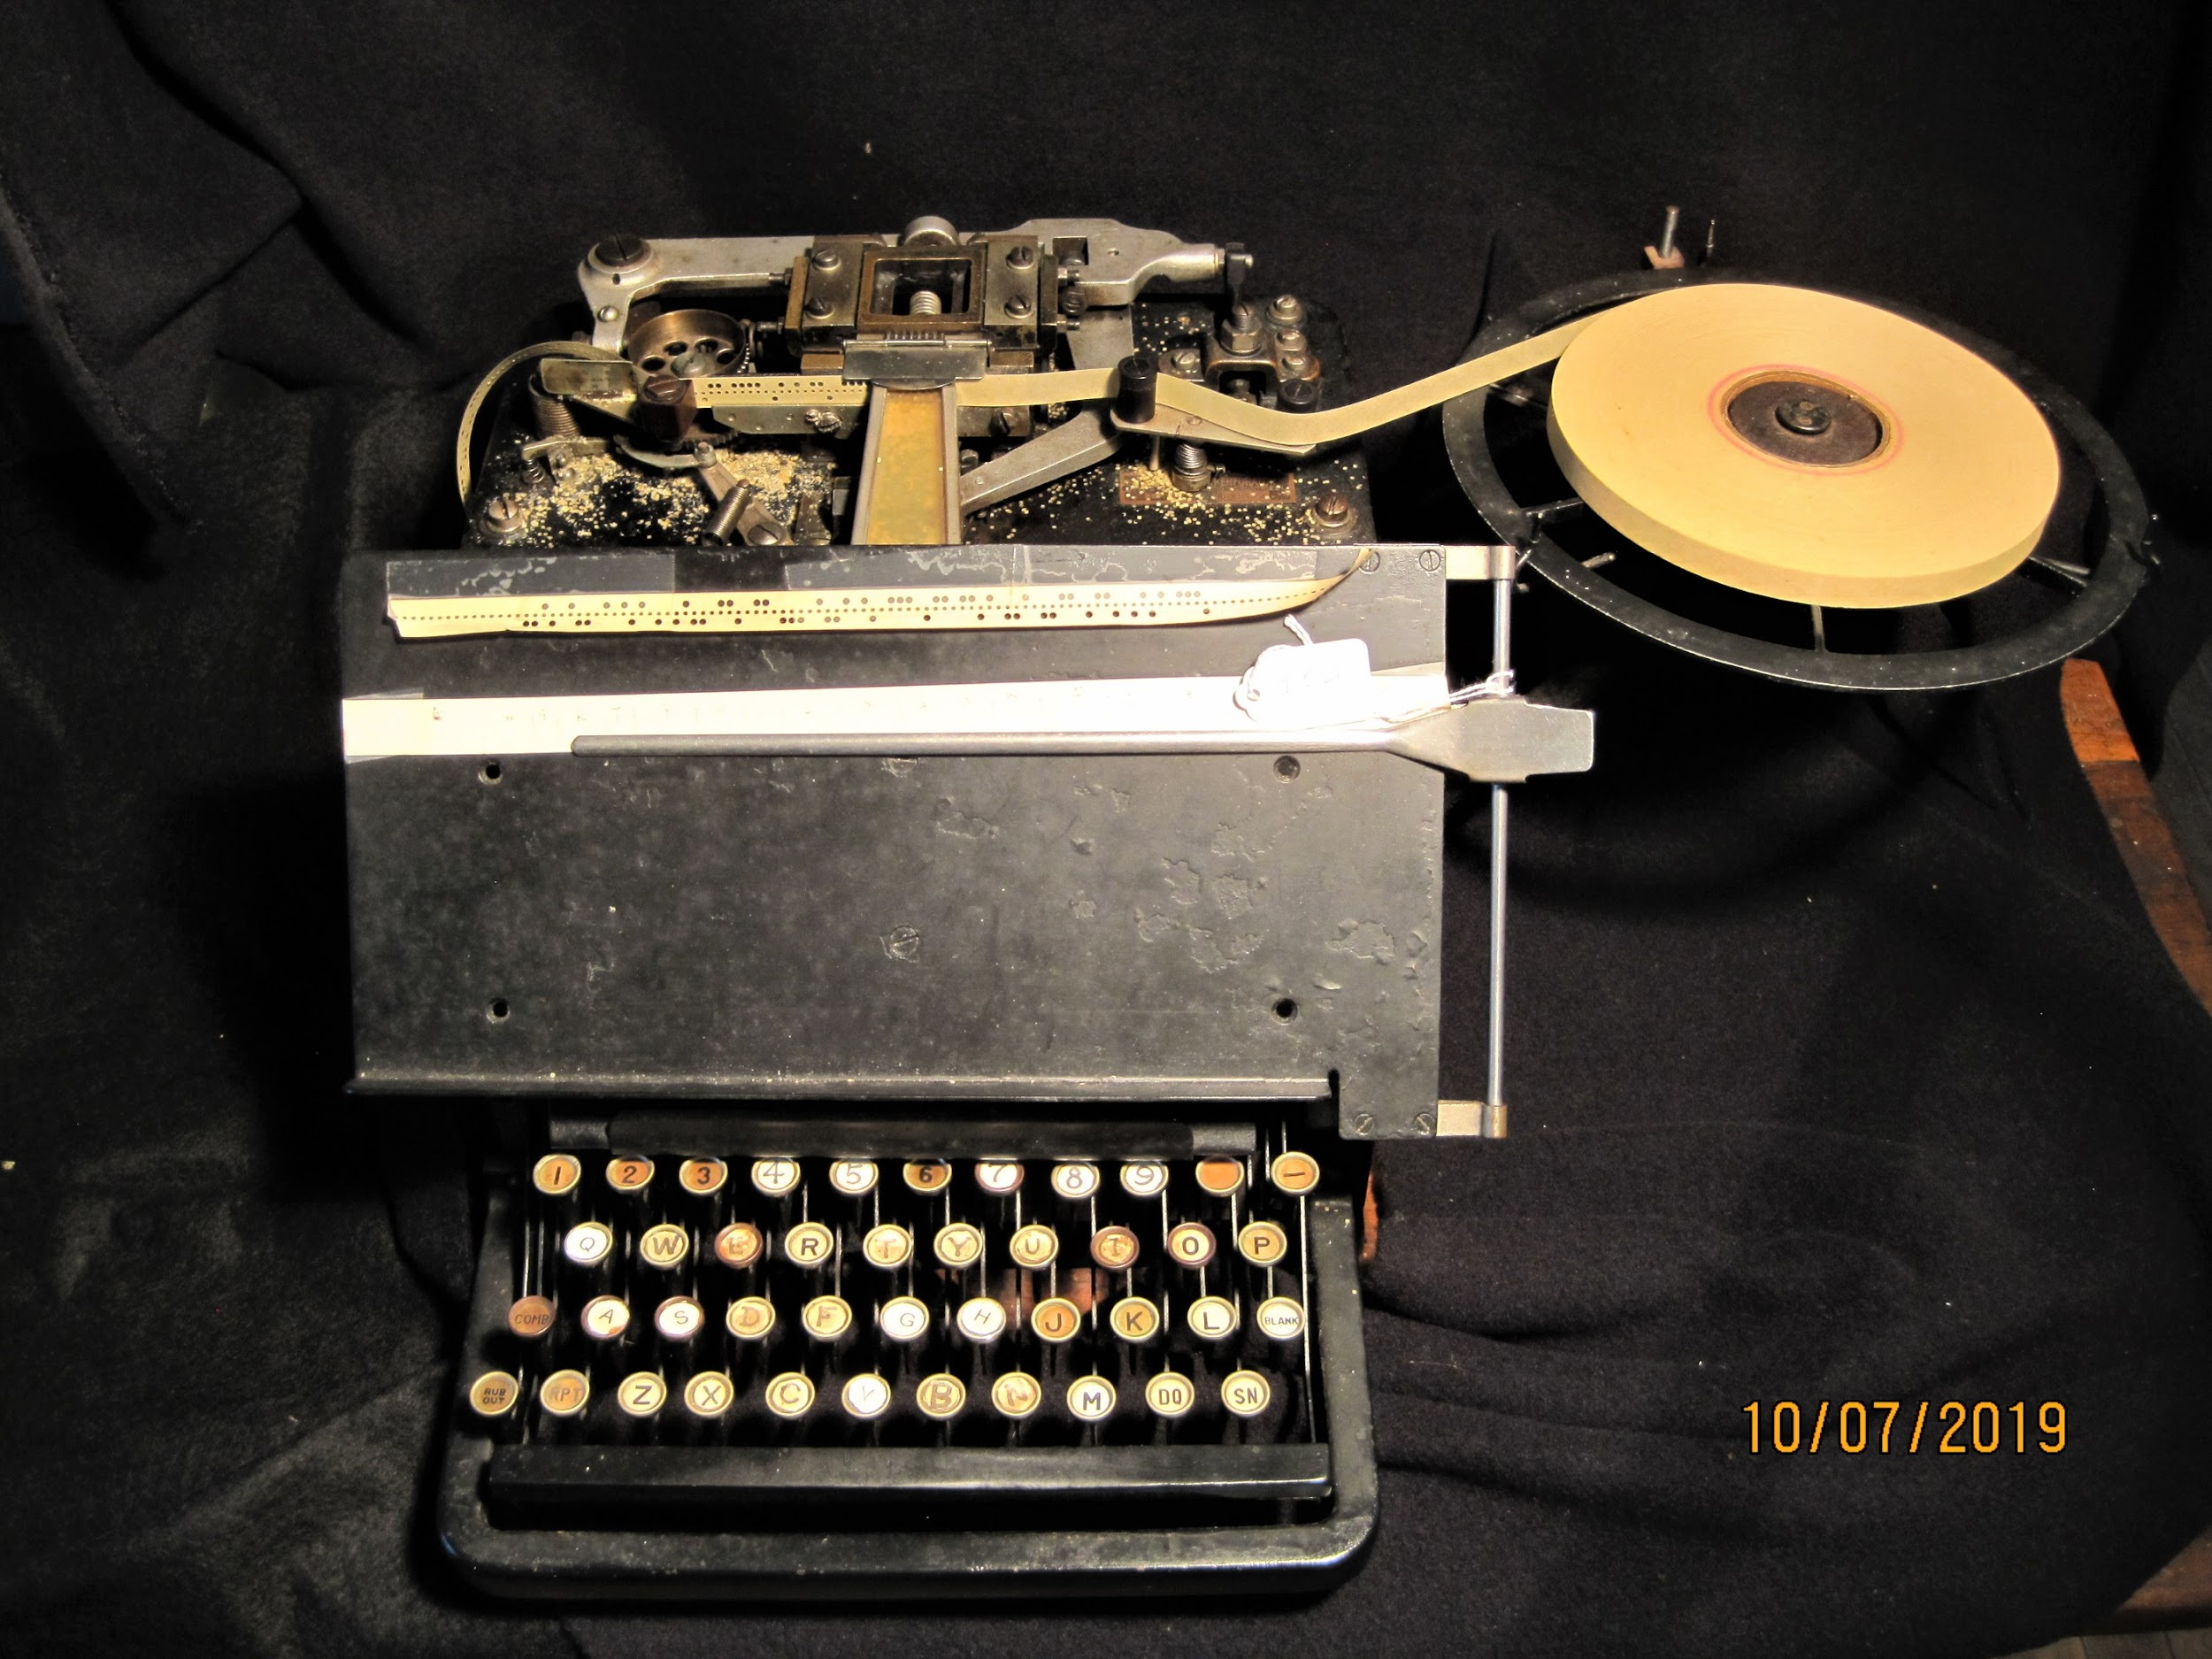
Keyboard perforator

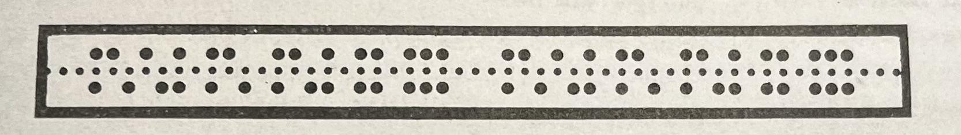
Perforator strip

Incoming telegrams on radio were initially received manually on telegraphy and typewriter or on a connected strip printer but was also later replaced by a mechanical system. Outgoing telegrams could be sent on hand-held telegraphy but was soon replaced by a high-speed system, Wheatstone with transmission speeds from 20-25 up to 100 words per minute.

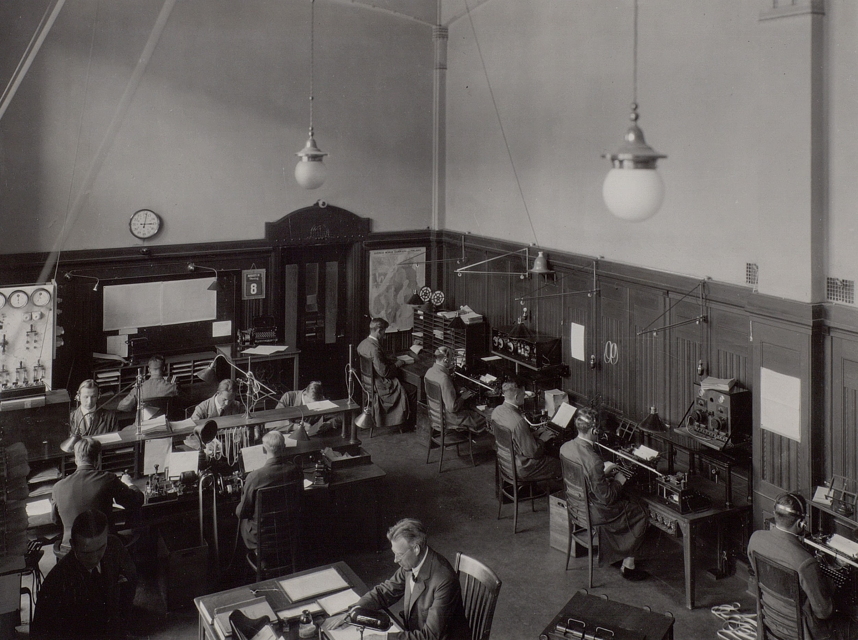
Radio Control center in Göteborg

The number of satisfied customers increased steadily. Statistics from the Radio Control Center showed 102 988 telegrams sent via Grimeton and 44 315 received via Kungsbacka. About 10 % of the traffic was transit to and from abroad. The statistics also showed that 95 % of outbound US traffic went via Grimeton compared to only 45 % received via Kungsbacka. Competition from established cable companies controlled the traffic from USA.

Shortwave
The Point to Point longwave traffic in all its glory, but with new technology shortwave developed at a furious pace. Sweden was one of the countries that first started using
shortwave equipment on board merchant ships. The Telegraph Office gave the merchant navy’s telegraph operators permission to use their equipment onboard for shortwave transmission tests with Göteborg Radio where a temporary 40W tube transmitter was installed.
The permit also included the possibility of contacting Swedish radio amateurs who had previously been relegated to wavelengths below 200 meters, which were then considered to have no value for commercial radio traffic.
The merchant ships’ shortwave tests gave surprisingly good results. Göteborg Radio began exchanging traffic with Swedish American Line passenger ships on the North Atlantic and it was perhaps via the small shortwave transmitters that the filmstars of the time received good luck telegrams on their way to Hollywood.

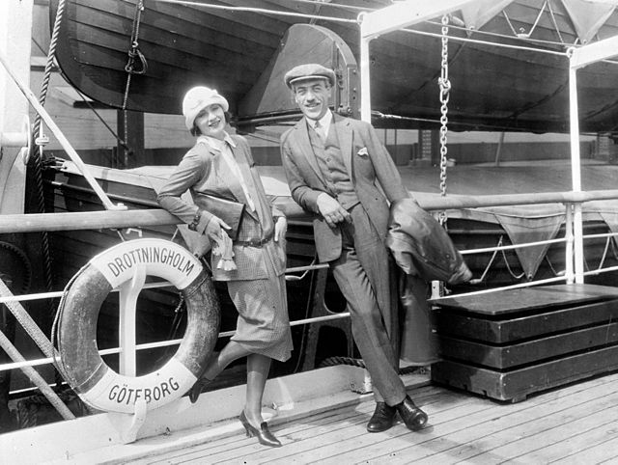
Hollywood stars Greta Garbo and Mauritz Stiller

Radio amateurs
It was the experimental radio amateurs of the time, with the first permits as early as 1913 and later in the 1920s, who discovered the way to shortwave. There was initially no regulation in Sweden for amateur radio, but now the authorities had woken up. In a clip from the magazine Radio from 1924 it is said that:
”It is engineer Fant, who just recently had his station in Norrviken officially named with the letters SMZZ. We hope that this our first amateur radio station will soon be able to count many comrades. Several already exist although they have not yet received recognition to have been assigned a call sign, depending on the fact that it has only
nowadays been decided which letter series will be used for Swedish amateur radio stations.

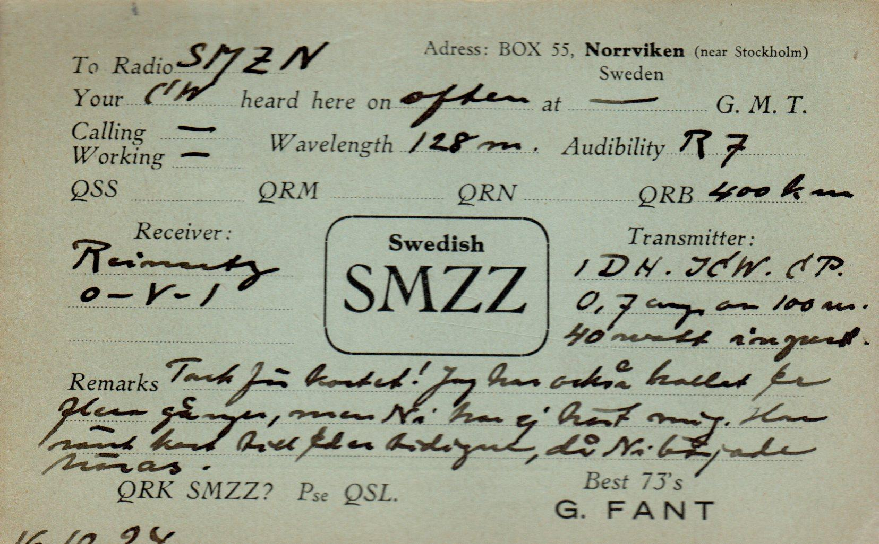
Amateur radio QSL-card from 1920

To obtain a Swedish amateur radio license at that time a submission request for a concession was required to be submitted to the Swedish Parliament which in council granted this permission under certain conditions.
In a later newspaper quote from the same year, one could also read about this following historical event. Technologist T Elmqvist SMZS:
On December 5th at 1120 in the evening the tests with SMUX were completed and I listened on ”American waves” around 75-85 meters. Among several stations I suddenly heard C1AR in contact with an American. He signed off at 1125 and I thought that a random call couldn´t hurt before I closed for the evening. I called C1AR de SZMS QRK? ere QSA. I called him for 5 minutes and switched over to receive. I got response from a very strong station. My first thought was that this must be a station from Europe interfering so I couldn´t hear the Canadian. But what is this? He calls himself C1AR and is now calling SMZS C1AR!
The explanation was that he had increased his power a lot and was now so strong that he could be heard as R8 i.e. with the earphones on the table. Maybe my eardrums were more sensitive than usual. After his call, this came: FB GREETINGS TO 1ST SWEDE TO WORK AMERICA = Pse QRA?
I answered immediately: Ere QSA R8 and then my address. Then he replied: OK QSA Ere msg SMZS =
Greetings from ARRL world over.

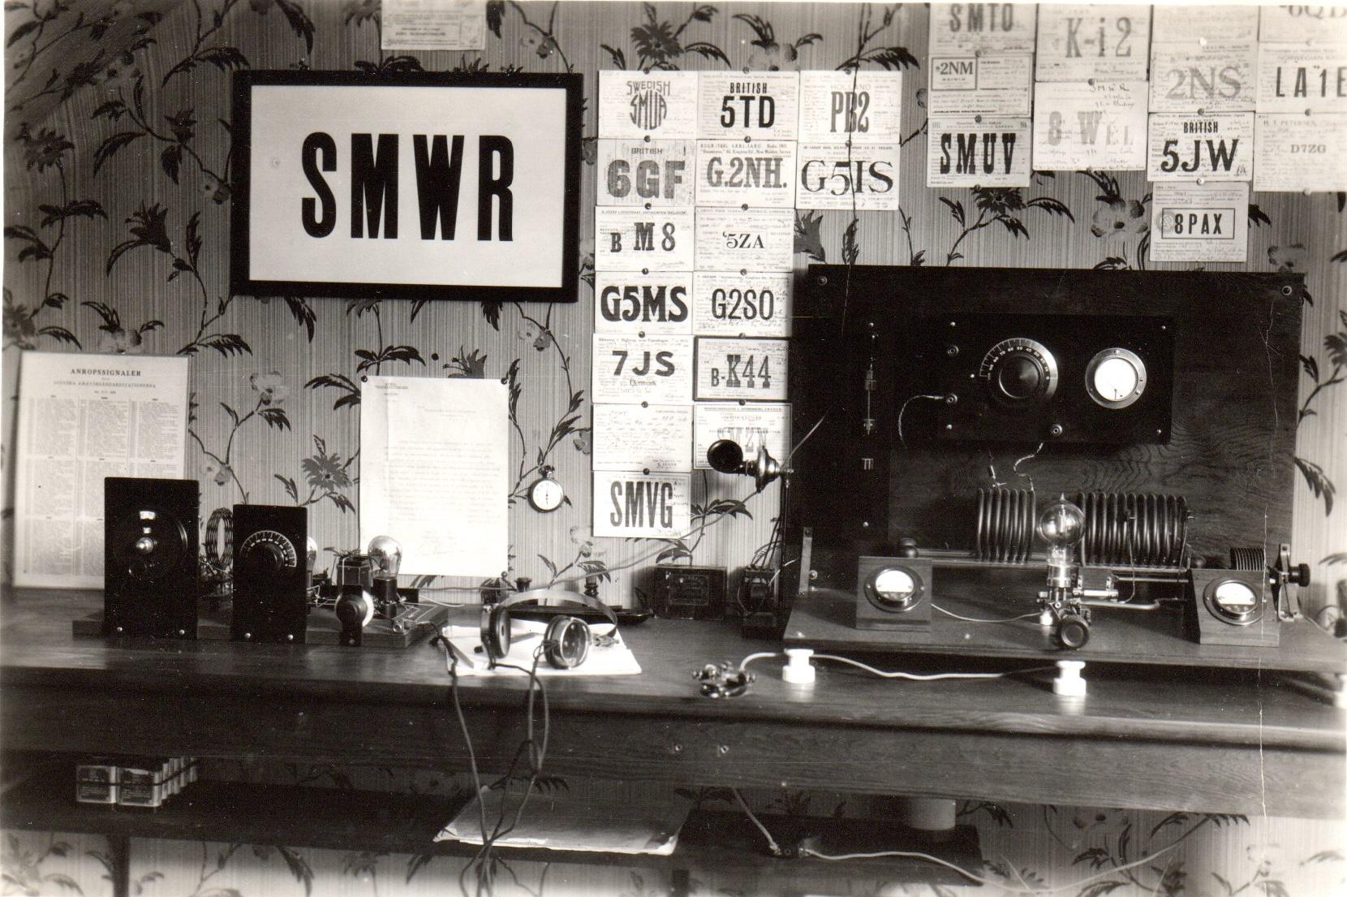
Amateur radio station from the late 1920s

Shortwave now began to take over much of the commercial telegram traffic. A new powerful transmitter was installed in Karlsborg 1930. Göteborg Radio moved
all operators and all shortwave reception to Kungsbacka with new receivers as Reinartz-Hartley and Marconi Rg16 and new remote controlled Marconi transmitters in Göteborg with SAG as new call sign on shortwave. Several shortwave receiving antennas were installed around the station building in Kungsbacka. The staff doubled when radio watch was introduced around the clock for the Point to Point traffic with USA and Europe and for shortwave traffic with the merchant fleet on the world’s oceans. Monitoring shortwave reports from Kungsbacka to the Radio bureau in Stockholm telling about good signals in the evening from WQO Long Island on 44 m and WIR New Brunswick on 74 m. English stations such as GBM on 56 m and G5DH on 52 m as well as several stations in France and Germany were also included in the report.

The traffic to Europe on both longwave and shortwave now increased dramatically. Karlsborg had previously handled transmissions of weather forecasts and press news and also daily fixed traffic with several countries in Europe. To relieve the pressure on Karlsborg another long wave antenna was built in Kungsbacka. A 7,4 km long Beverage antenna in direction southwest for Europe and was also intended to be used for Japan.
Furthermore a number of 30 m high wooden masts were erected for horizontal shortwave antennas, a 300 meter long horizontal antenna facing east, a 3 sq m frame antenna for Baltic traffic and an additional horizontal wire in direction west.

FROM: Radio Bureau in Stockholm

TO: Telegraph Commissioner, Göteborg Radio

= TRAFFIC ORDER =

The following message shall be sent after the press news for 14 days:

Shortwave traffic with Göteborg Radio is arranged from Dec 1st 1930 in such a way that the station will operate 24 hours a day on 36,4 m wavelength until further notice. The station transmits every four hours starting at 1200 Swedish time, if not busy with correspondence and in such a case immediately thereafter, CQ signal accompanied by the station´s
traffic list. Ship telegraphists are requested to record in the passage log the approximated distances at which the shortwave dispatch with Göteborg Radio
took place. Shortwave traffic with Härnösand Radio and Vaxholm Radio will not be allowed from the above mentioned date until further notice.

Stockholm 22 nov 1930
Royal Telegraph Radio Board

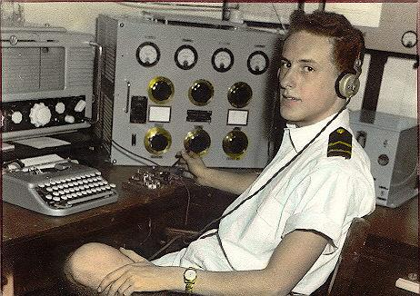
”Spark” Merchant navy radio operator

The amount of traffic that has arisen on both longwave and shortwave was not planned for when the station was built in Kungsbacka 1923. The longwave antennas at great distances from the receivers and built on the former seabed with a clear view of the sea worked perfectly. Unfortunately, this was not the case with a number of shortwave antennas placed in the narrow area around the station building where new villas and small houses were getting closer and closer. Shortwave traffic with merchant ships and fixed traffic with Europe worked well. The problem was the shortwave traffic from USA.

Report to the Radio bureau in the fall of 1931:
……Shortwave traffic from USA to Sweden leaves a lot to be desired. The Radio Control Center in Göteborg is repeatedly criticized for the fact that Sweden can not receive shortwave when other countries can. However, it does not seem relevant to me to provide the receiving station in Kungsbacka with new equipment.
The antennas at such a facility require comparatively large land areas which would hardly be possible to find at a reasonable distance from the station…

Several questions arose when the Swedish State railroad Company announced that electrification of the West Coast Railway, Göteborg - Malmö was under planning. A local electric power company also announced that a new electric power line was to be built in the area. In addition to this, a new local railroad track was also planned.
Both electric lines and the railroad track came to cross the long USA-antenna.
After some investigation it was decided to temporarily place parts of the antenna in a tube tunnel under the railway track and power line. Total 275 meters under ground.

In addition, in order to achieve a more stable traffic flow between Europe and USA. RCA established a relay station in Tanger, North Africa. Traffic from Grimeton and Karlsborg was supposed to go via receivers and transmitters in Tanger and automatically on to New York.
In the same way, back from USA to Sweden.

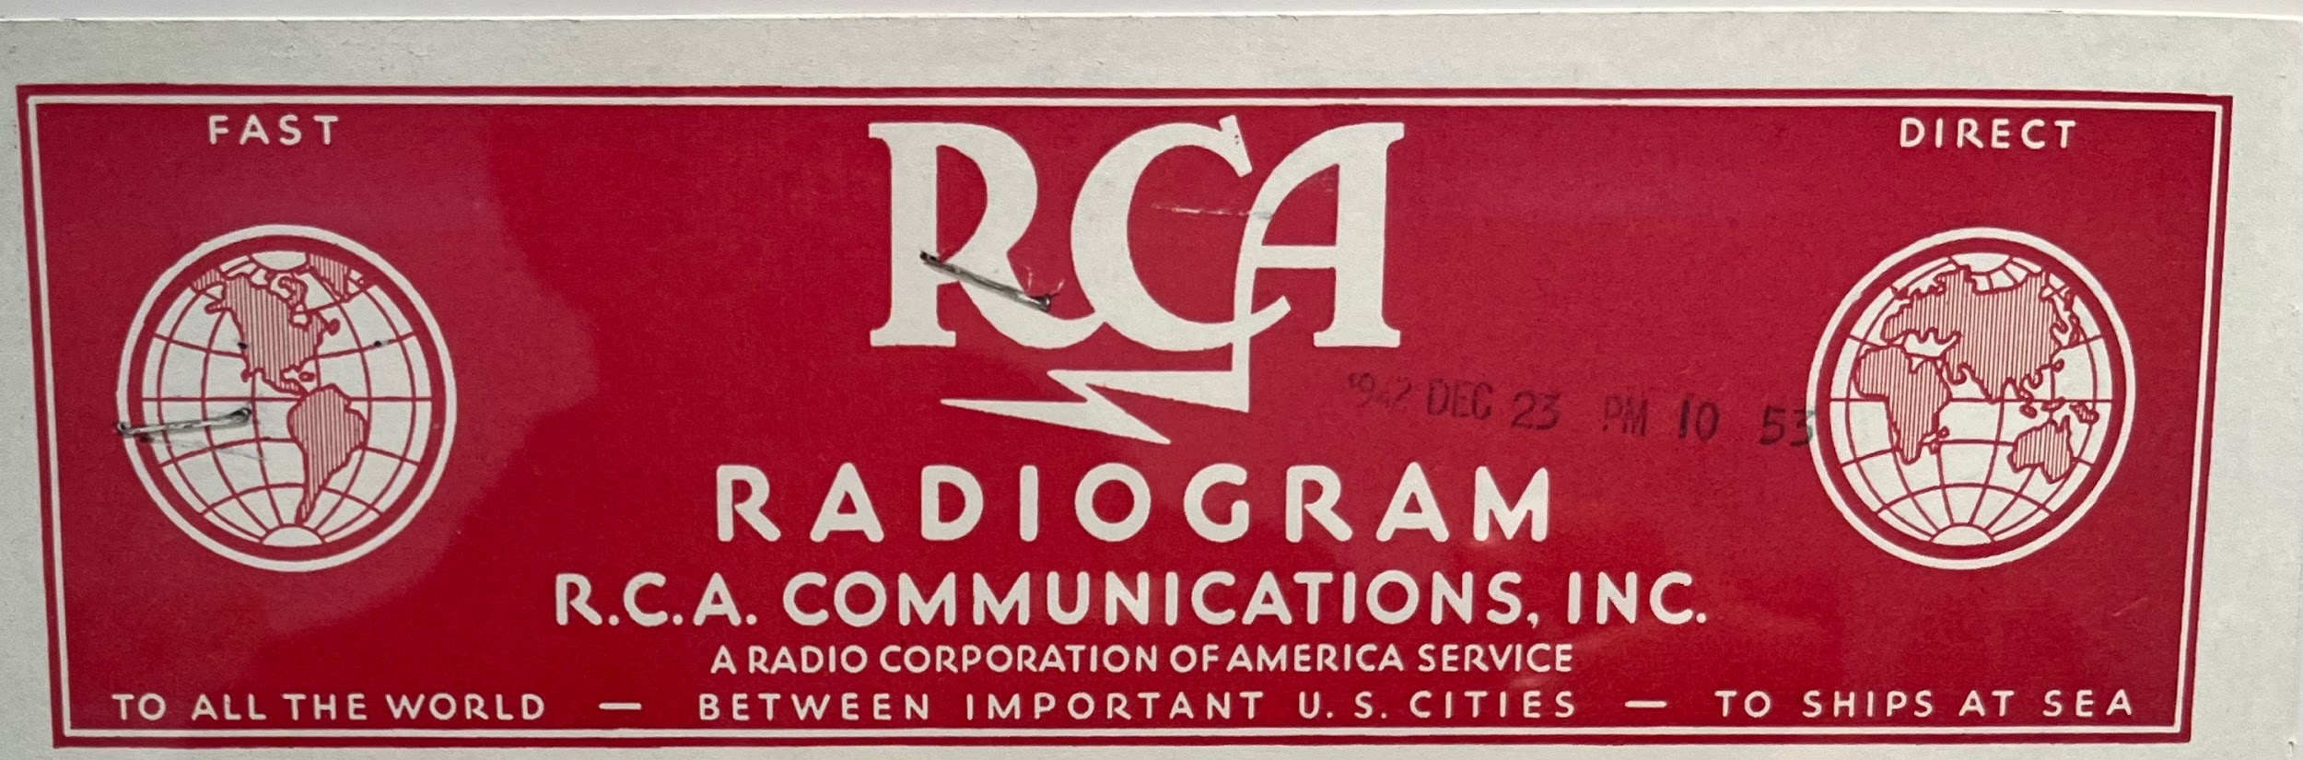

Despite this possible improvement Radio Office realized that the conditions for Kungsbacka Radio had changed completely since the start in 1923. The vicinity to a growing community made the situation unsustainable in the long run. A completely new receiving station was needed.

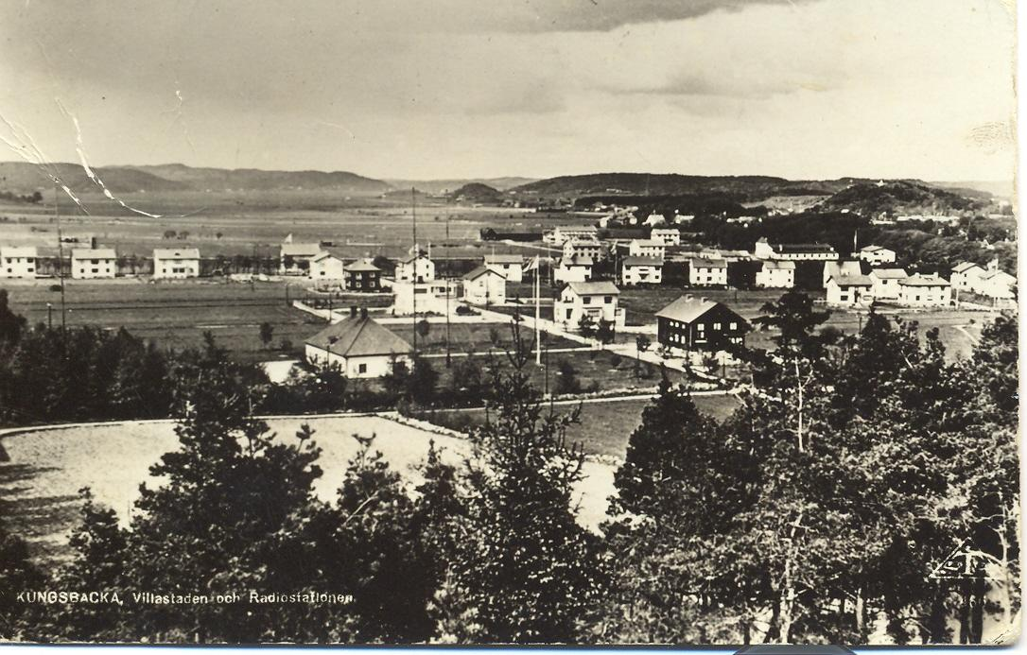
Kungsbacka Radio 1930

With new technology shortwave traffic with the merchant fleet also increased in a way that could not have been predicted at all. Göteborg Radio had outgrown its costume in just a few years and it became very cramped.
Several reports to the radio Office in Stockholm about the current situation resulted also in new planes for traffic with the merchant Navy.

Enköping Radio
In the spring of 1937 a completely new radio station, Vallby Radio, was built outside Enköping to take over the roll as receiving station for fixed traffic with USA, Europe and the rest of the world. In the summer of 1938 the station was completed and became the main receiving station of the radio system. Kungsbacka radio remained as receiving station for European traffic.

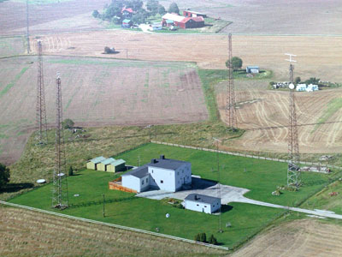
Enköping Radio

The Radio Control center was moved from Göteborg to Stockholm and in the same way as before, coordinated all traffic via the transmitters in Grimeton/Karlsborg and the receivers in Enköping and Kungsbacka.

After a parliamentary decision, planning also began for a new coast radio station, for merchant shipping, to be located closer to the sea outside Kungsbacka.
Work began during the summer of 1939 but was interrupped by the outbreak of WW2 in September.

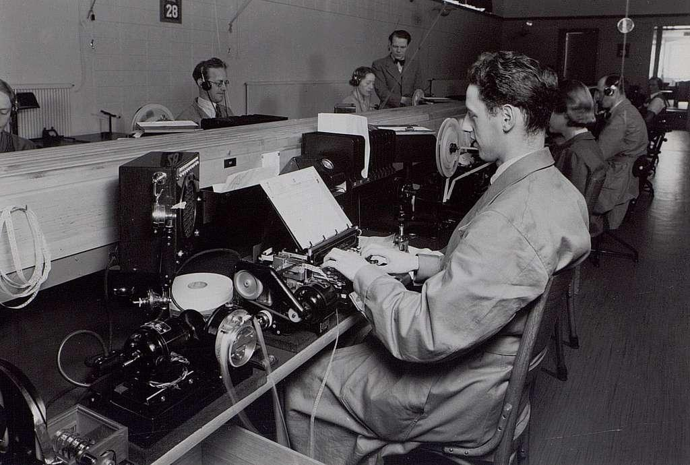
Radio Control center in Stockholm

World War 2
During WW2 the Swedish radiosystems were seen as one of Scandinavia’s few ways of contact with the outside world. Göteborg Radio lived under constantly restrictive regulations. Merchant ships were prohibited from using their transmitters within certain risk zones. At the request of the sender, traffic could therefore be blindly sent to the ships without confirmation.
Sometimes Göteborg Radio radio was called by stations with strange call signs belonging to resistance groups out in Europe. They asked for help in getting messages to their embassies in Sweden.

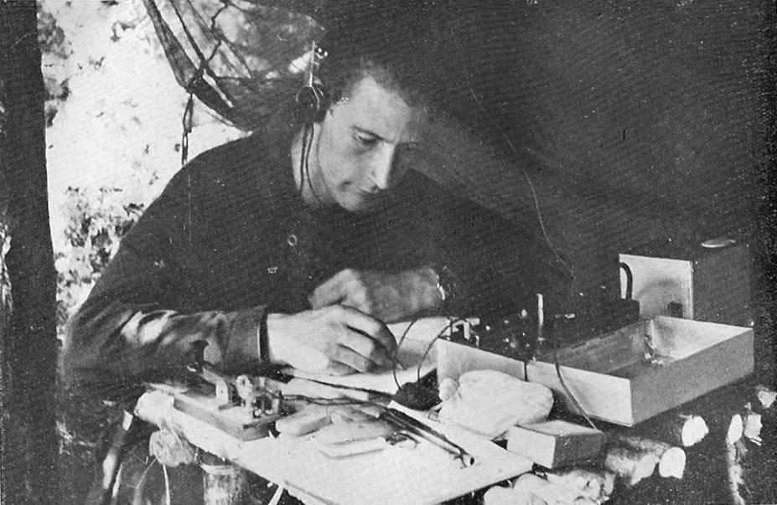
Secret radio station…

The Swedish courier flights also used the coast radio to report when entering Swedish airspace during flights from England and Scotland.
By the end of the war normal telecommunications were destroyed in many places. Göteborg Radio was asked to convey traffic and among other things was asked to act as contact point to Poland via Gdynia Radio regarding inquiries from Swedish authorities and private individuals about missing persons in Poland.
The fixed radio traffic via Sweden was for certain countries the only way to contact the outside world and very important. During the first post-war years, Sweden was able to start up with very well functioning international radio systems. Radio Control Center in Stockholm operated a large number of transmitters for shortwave and longwave in Grimeton and Karlsborg. All incoming traffic was centralized to Enköping Radio.
The international coast radio traffic on shortwave and longwave was controlled by the new Göteborg Radio, which had moved operations from Göteborg and Kungsbacka to Onsala peninsula close to the sea. Sweden was ready for the challenges of the new era…

